
More Efficient Cattle Operations
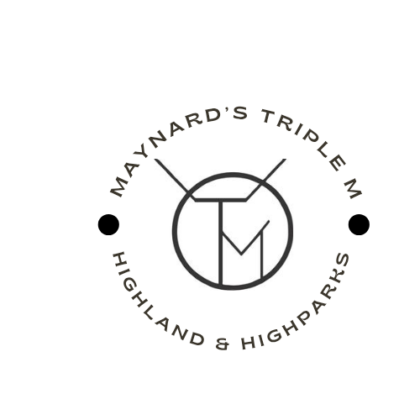
Marketing, Planning & Daily Work with ChatGPT
Instructor: Amy Maynard
Maynard’s Triple M — Highlands & Highparks
Practical tools for real ranch life.
Format: 3 Live Zoom Sessions (60 minutes each)
Plus: Optional Thursday Open Discussions
OnDemand: Sessions will be recorded and available to watch anytime following the live session via the learning portal at cowgirlconfident.net

Live Teaching Sessions (Tuesdays)
Session 1 – Tuesday, January 13 at 8:00 pm CST
Foundations & Personalization for Cattle Operations
- Customizing ChatGPT to reflect your operation and values
- Custom Instructions for cattle producers and educators
- Building a consistent, professional ranch voice
- Practical buyer, planning, and communication examples
Session 2 – Tuesday, January 20 at 8:00 pm CST
Memory, Privacy & Responsible Ranch Use
- Managing memory safely and intentionally
- Using Temporary Chats for sensitive conversations
- Privacy considerations for marketing and operations
- Teaching ethical boundaries aligned with real ag life
Session 3 – Tuesday, January 27 at 8:00 pm CST
Advanced Tools, Collaboration & Teaching Others
- Productivity tools for daily cattle operations
- Using voice, files, and repeatable workflows
- Collaboration tools for families, partners, and teams
- Teaching ChatGPT use with confidence

Open Discussion & Work Sessions (Thursdays)
- Open Zoom room for additional learning
- Guided discussion and real-world application
- Amy available for questions and hands-on setup support
- Time to refine scheduled work and workflows

Included With Registration
- Downloadable cattle-operation focused workbook
- One-page quick reference guides
- Live demonstrations using real ag scenarios
- Interactive discussion and Q&A
- Optional certificate of completion

